Gmail Email Management & Auto Reply Automation

Project Overview
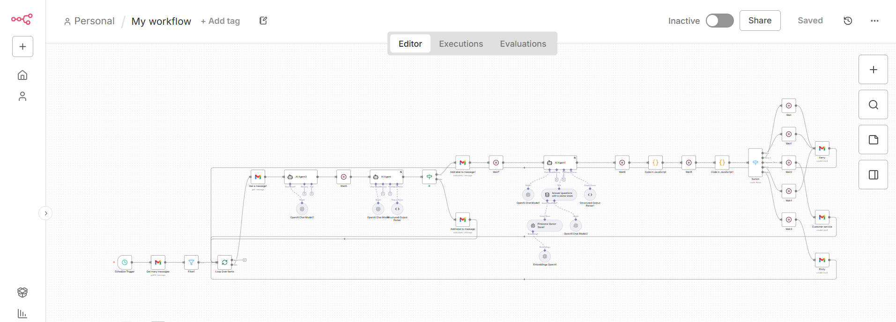

An automated Gmail management system built with n8n to organize incoming emails, apply the right labels, route messages to the appropriate team, and prepare replies as drafts.
The system handles inbox processing automatically while keeping final control over outgoing emails with the team.

Workflow
The system:
• Monitors incoming Gmail messages
• Checks whether an email has already been processed
• Categorizes emails based on their content and priority
• Applies the appropriate Gmail labels
• Identifies emails that require a response
• Generates draft replies using company information
• Extracts sender details for personalization
• Routes emails to the relevant team member
• Creates properly formatted Gmail drafts with subjects and signatures

Knowledge & Routing
The workflow uses a knowledge base to provide relevant information when preparing replies.
Emails are also routed based on their category, ensuring messages reach the appropriate department or team member.

Platforms & Technologies
• n8n
• Gmail API
• Pinecone
• JavaScript
• Webhooks
• API integrations

Key Features
• Automated inbox management
• Email classification and labeling
• Duplicate prevention
• Priority based routing
• Draft reply generation
• Knowledge base integration
• Team based email routing
• Human approval before sending
• Automated email processing

Result
A streamlined email management system that reduces manual inbox work, keeps emails organized, routes messages correctly, and prepares consistent replies while keeping the final sending decision with the team.

